**HW - Week 11**

**Name:** Sahand Sabour **Student ID:** 2020280401

**Page 93:**

4.4-7)

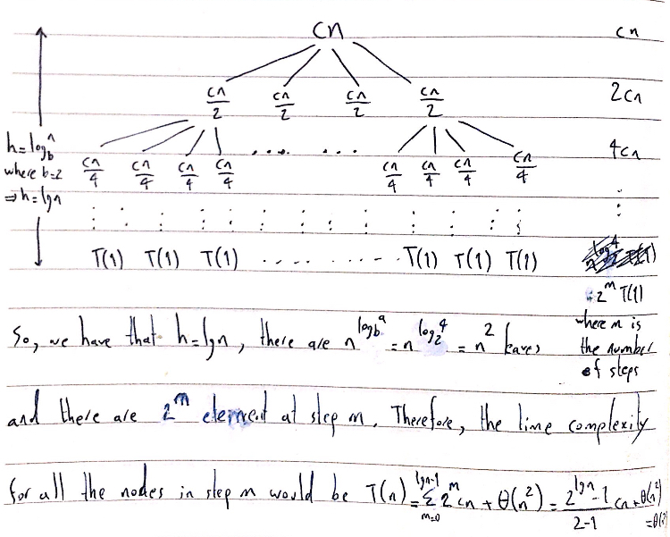

Hence, given T(n) = Θ(n2), we have that the upper bound is O(n2) and the lower bound is Ω(n2). Accordingly, we use substitution to provide the tightness of these asymptotic bounds (prove that this guess , which states T(n) = O(n2) as the upper bound, is correct). Therefore, using given constants d and e>0, we get that

$$T(n)≤4t[n/2]+cn$$

$$≤4d{[n/2]}^{2}+cn$$

$$≤4d{(n/2)}^{2}−4(d’n/2)+cn$$

$$=dn^{2}−2d’n +cn$$

$$≤dn^{2}−d’n$$

Where $d’$ >c. Therefore, the upper bound is T(n) = O(n2). Accordingly, for the lower bound, we want to prove that T(n) = Ω(n2). Hence, for a given constant d>0, we have

$$T(n)≥4t[n/2]+cn$$

$$≥4d{((n/2)−1)}^{2}+cn$$

$$=dn^{2}−4dn +cn+4d$$

Where -4d+c≥4. This proves that the lower bound is T(n) = Ω(n2).

**Page 107 - 4-1:**

B) For this recurrence a = 1, b= 10/7, and f(n) = n. Therefore, we have that

$$n^{\log_{b}^{a}}=n^{\log_{10/7}^{1}}=n^{0}=1$$

Since f(n)= ${Θ(n}^{\log_{10/7}^{1+ϵ}})$, where $ϵ=\frac{3}{7}$ and af(n/b) = f(7n/10) ≤ cf(n) where c= 7/10 < 1, by the case 3 of master theorem the solution is T(n) = Θ(f(n))= Θ(n).

C) For this recurrence a = 16, b= 4, and f(n) = n2. Therefore, we have that

$$n^{\log_{4}^{16}}=n^{2}$$

Since f(n)=Θ($n^{\log_{4}^{16}}$), then by the case 2 of master theorem the solution is T(n) = Θ($n^{\log_{4}^{16}}lgn$) = Θ($n^{2}lgn$).

D) For this recurrence a = 7, b= 3, and f(n) = n2. Therefore, we have that

$$n^{\log_{b}^{a}}=n^{\log_{3}^{7}}$$

Since f(n)=Θ($n^{\log_{3}^{7+ϵ}}$), where $ϵ=1$ and af(n/b) =7 f(n/3) ≤ cf(n) where c= 7/9 < 1, by the case 3 of master theorem the solution is T(n) = Θ(f(n))= Θ(n2).

**Page 107 - 4-2:**

B) The worst-case running times for each strategy is provided respectively below:

1. T(n) = 2T(n/2) + Θ(n) so a=2, b=2, and f(n) = Θ(n). Therefore, we have that

$$n^{\log_{b}^{a}}=n^{\log_{2}^{2}}=n$$

Since f(n) =Θ($n^{\log_{2}^{2}}$), by case 2 of the master theorem the solution is T(n) = Θ($n^{\log_{2}^{2}}lgn$) = Θ($nlgn$).

1. T(n) = 2T(n/2) + Θ(N) = 4T(n/4) + 2Θ(N) + Θ(N) = $\sum_{i=0}^{lgn}{2^{i}}Θ(N)=Θ(n^{2})$.
2. T(n) = 2T(n/2) + Θ(n) so similar to part 1, by case 2 of the master theorem we have that T(n) = Θ($n^{\log_{2}^{2}}lgn$) = Θ($nlgn$).